**Assignment**

**Question 3**

Step 1: Create a feature branch.

Step 2: Switch to the new branch.



Step 3: open the file and make some changes to it.

Step 4: Add and commit the changes to the new branch.



Step 5: Push the changes to the new feature branch. 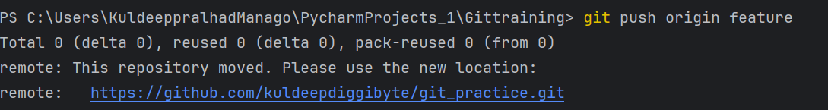

Step 6: As another user in the master branch make some changes to the same file.

Step 7: Add and commit the changes to the master branch.



Step 8: Push the changes to the master branch. 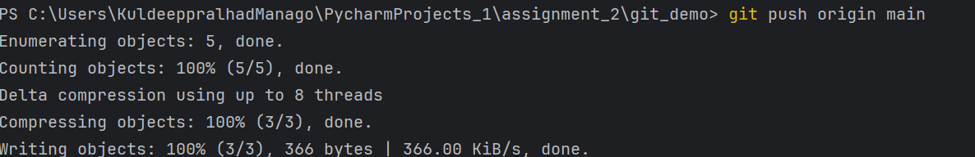

Note: There will be a conflict in the pull request, how do we resolve it??

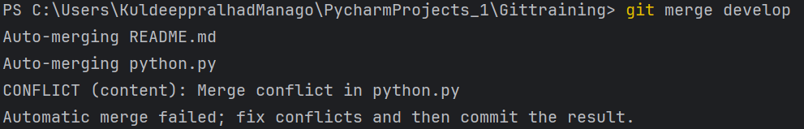

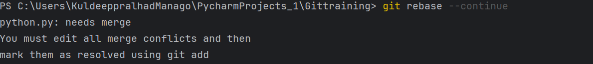

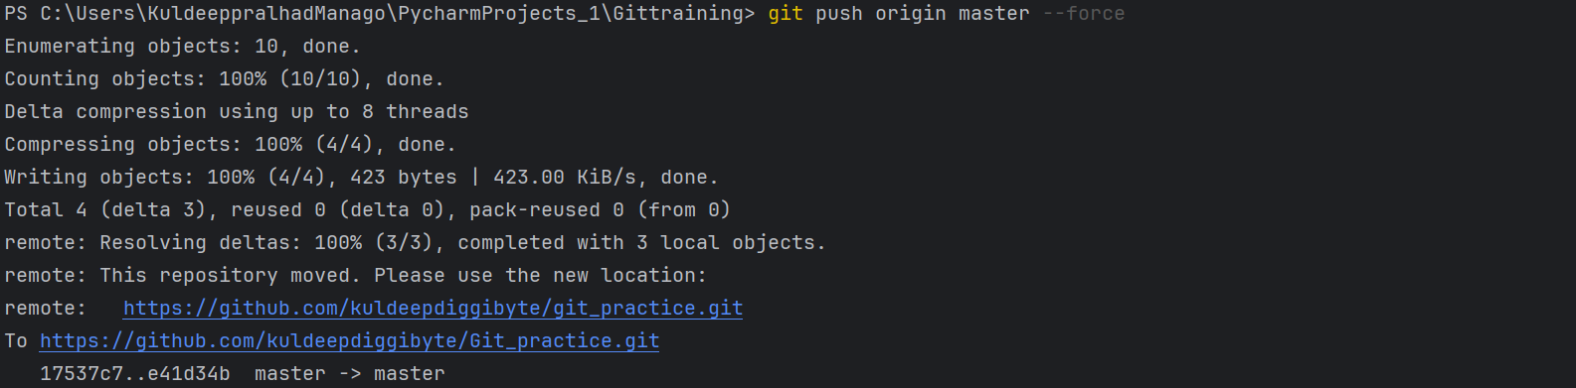

Hint: git rebase

